Blockchain 2
Assignment 1
Task 1: Factory Pattern Implementation Report
🔹 1. Overview
In this task, a Factory Pattern was implemented in Solidity to dynamically deploy child contracts on demand. The Factory contract is responsible for creating and managing multiple instances of ChildContract.
The goal of this implementation is to demonstrate how smart contracts can act as factories to deploy other contracts efficiently, while also comparing different deployment mechanisms (CREATE and CREATE2).

🔹 2. Contract Design
2.1 Child Contract
The ChildContract is a simple smart contract that contains:
- owner — address of the creator
- name — identifier of the contract
- balance — stored via contract balance
The constructor initializes the contract with the provided owner and name.
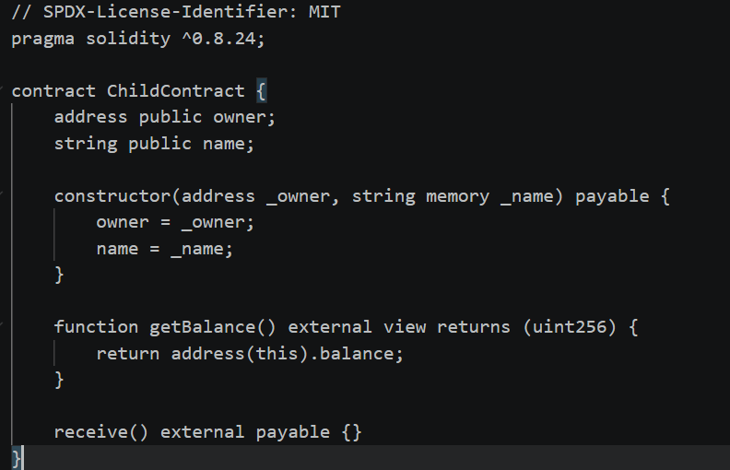

2.2 Factory Contract
The Factory contract performs the following functions:
- Deploys new ChildContract instances using:
  - CREATE
  - CREATE2
- Stores deployed contract addresses in:
  - an array (deployedContracts)
  - a mapping (isDeployedByFactory)
- Provides access functions:
  - getDeployedContracts()
  - getCount()
- Emits events for tracking deployments
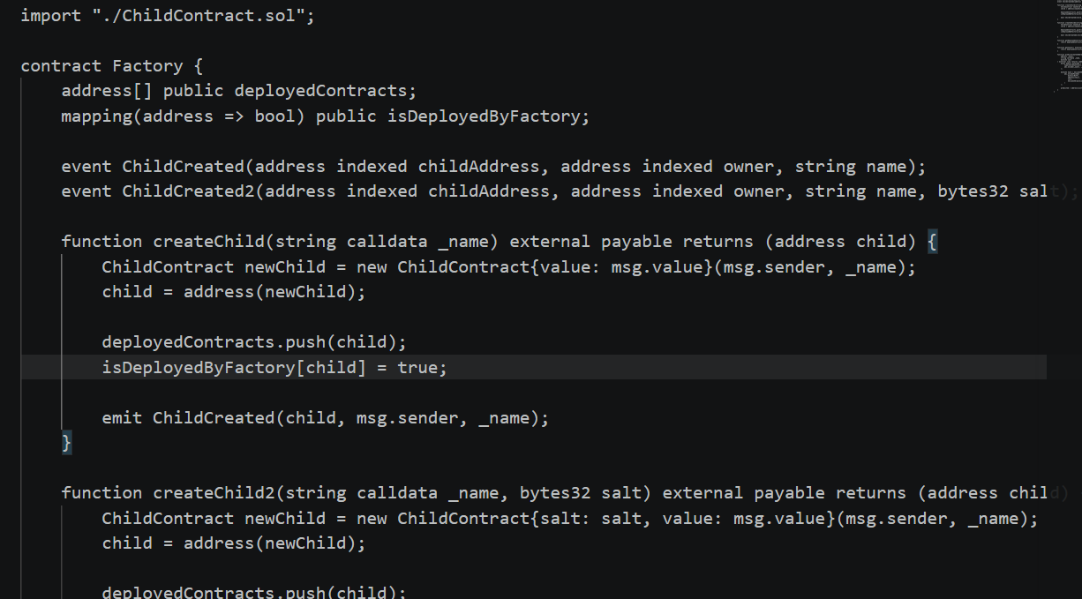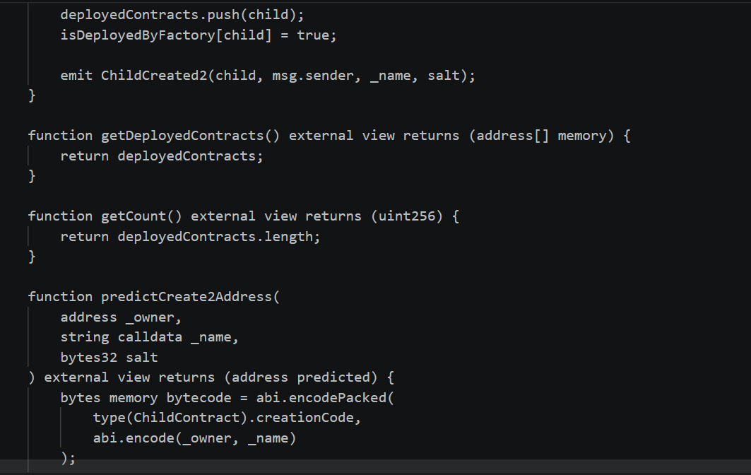
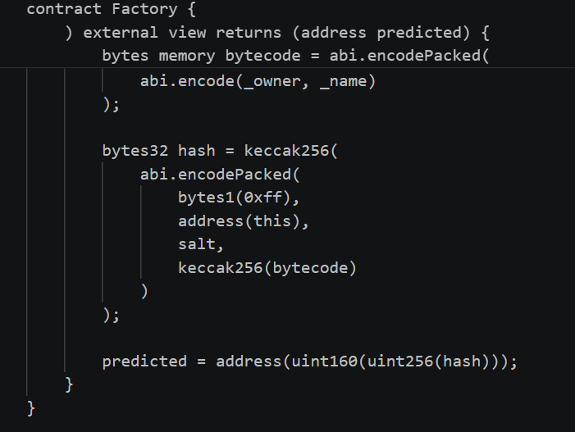

🔹 3. Deployment Methods
3.1 CREATE
The createChild() function uses the standard CREATE opcode to deploy a new contract.
Characteristics:
- Address is not predictable in advance
- Depends on sender address and nonce
- Simpler and commonly used
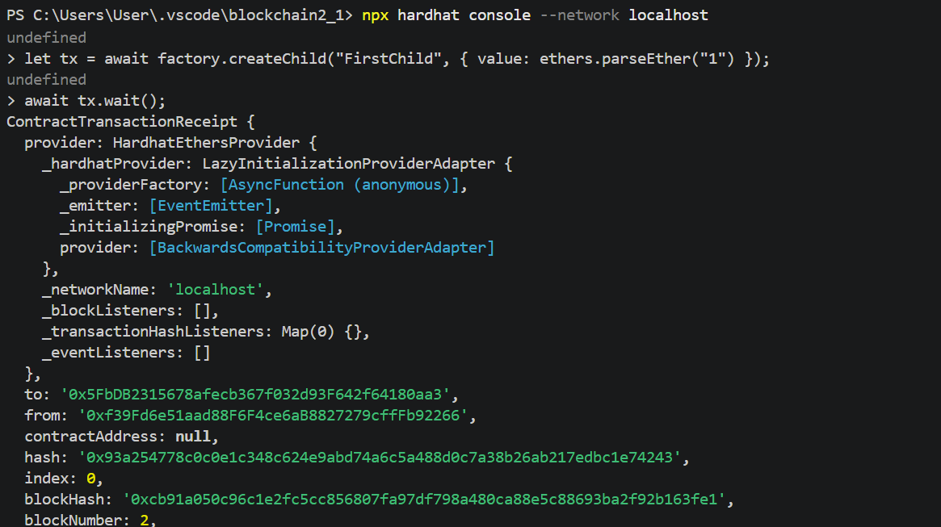
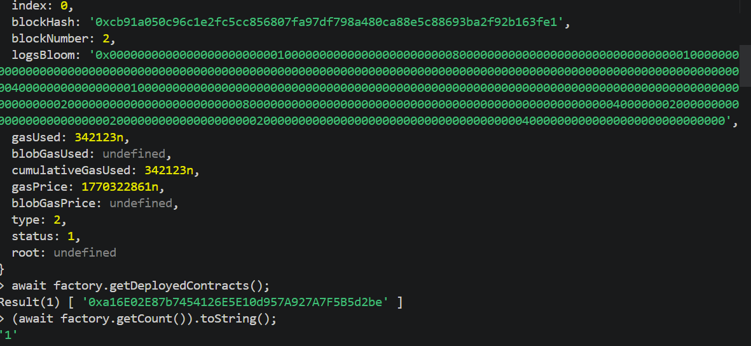

3.2 CREATE2
The createChild2() function uses the CREATE2 opcode with a salt.
Characteristics:
- Deterministic address generation
- Address can be predicted before deployment
- Useful for advanced use cases like counterfactual contracts
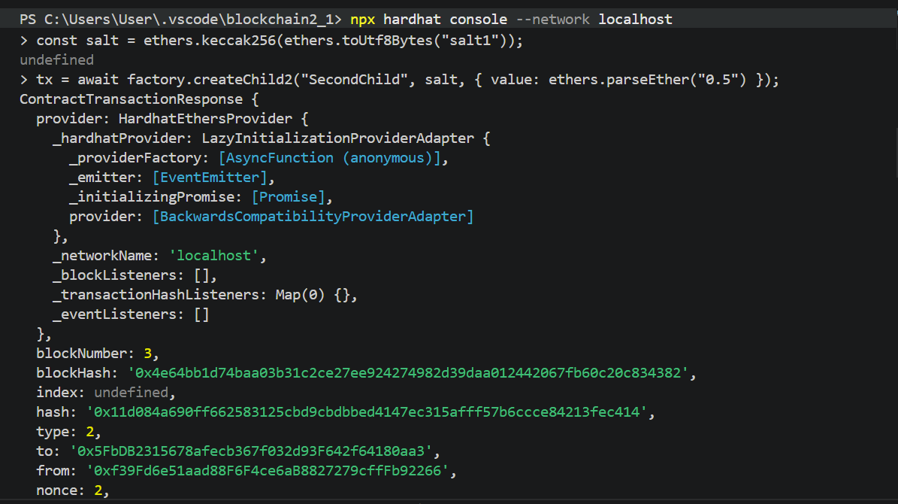

🔹 4. Address Prediction
The function predictCreate2Address() was implemented to calculate the expected contract address before deployment using CREATE2.
This demonstrates how deterministic deployment works in Ethereum.
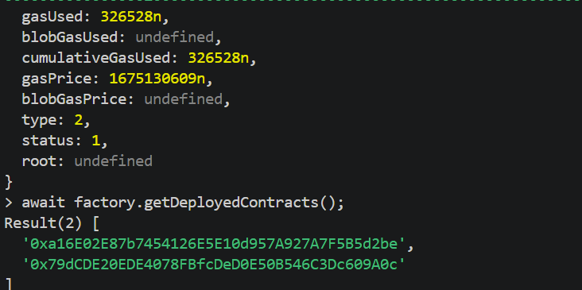
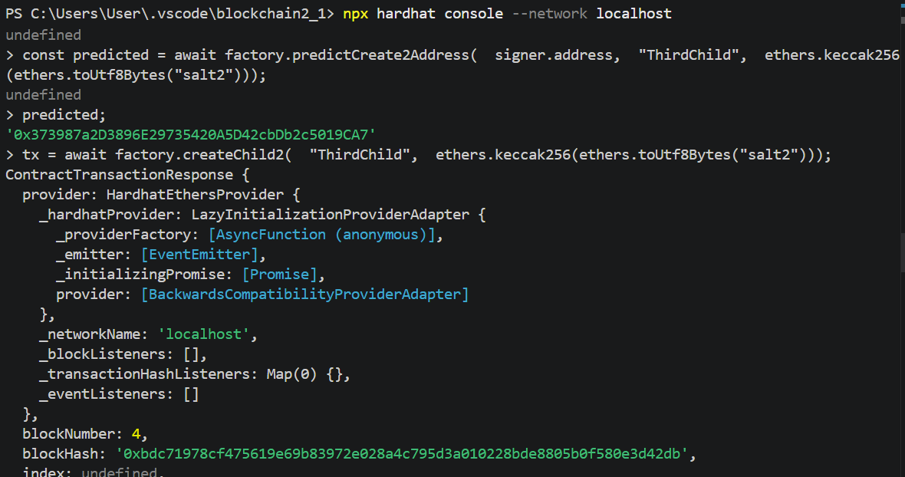

🔹 5. Gas Cost Comparison
Gas usage was measured for both deployment methods.
Method | Gas Used
CREATE | 342075
CREATE2 | 343568
Analysis:
- CREATE2 generally consumes slightly more gas due to additional hashing operations.
- However, it provides the advantage of deterministic addresses.
- CREATE is cheaper and suitable for most basic deployments.
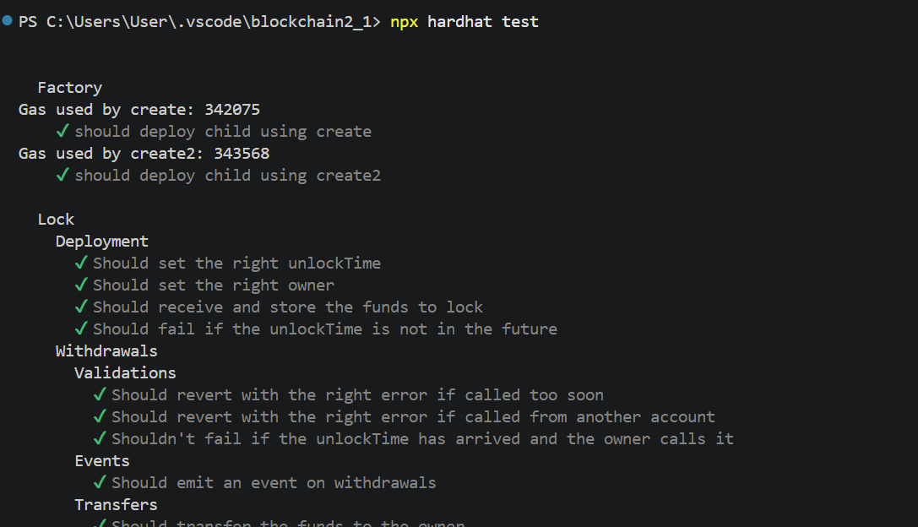

Task 2: Proxy Pattern & Upgradeable Contracts (UUPS)
1. Overview
In this task, the UUPS (Universal Upgradeable Proxy Standard) pattern was implemented to enable smart contract upgrades while preserving contract state.
Upgradeable contracts are essential in blockchain development because they allow modifying contract logic after deployment without losing stored data.
2. Implementation
Two versions of the contract were developed:
🔸 LogicV1
Implements a simple counter
Functions:
increment()
get()
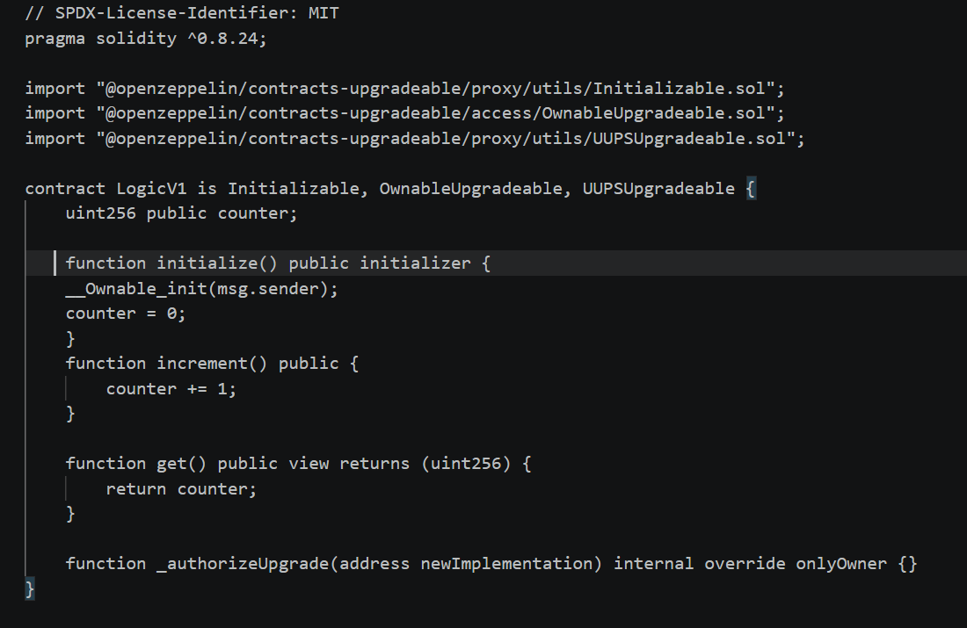🔸 LogicV2
Extends LogicV1
Adds new functionality:
decrement()
reset()
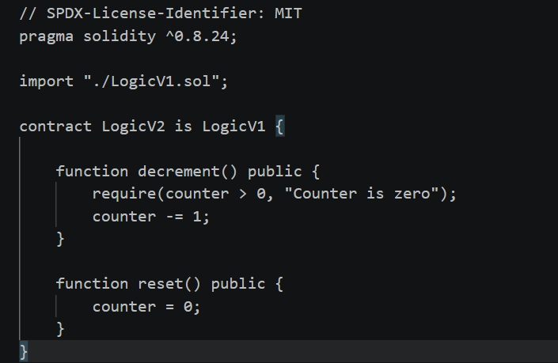
3. Deployment
The contract was deployed using the UUPS proxy pattern via the Hardhat Upgrades plugin.
A proxy contract was deployed pointing to LogicV1
The initializer function was used instead of a constructor
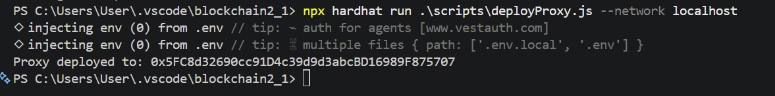 4. Upgrade Process
The upgrade process consisted of the following steps:
The proxy contract was deployed with LogicV1
The counter value was modified using increment()
The contract was upgraded to LogicV2
The state was checked after the upgrade
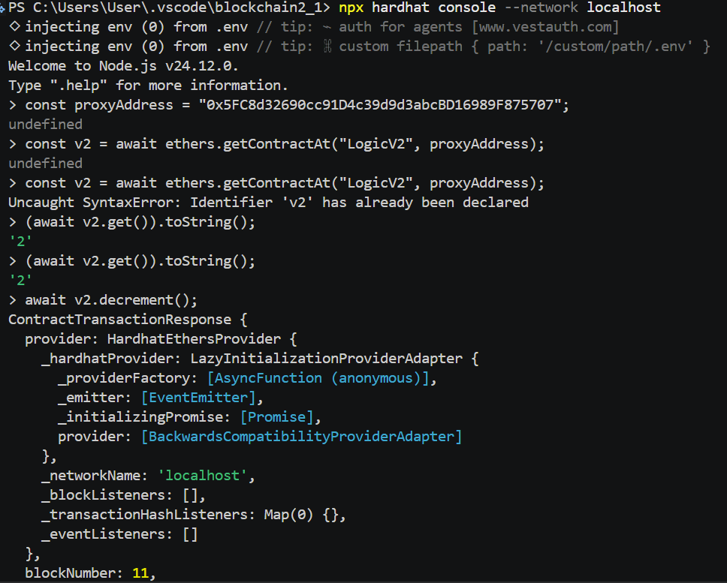 5. Results
The counter value remained unchanged after the upgrade
New functions from LogicV2 were successfully executed
The proxy address remained the same before and after the upgrade
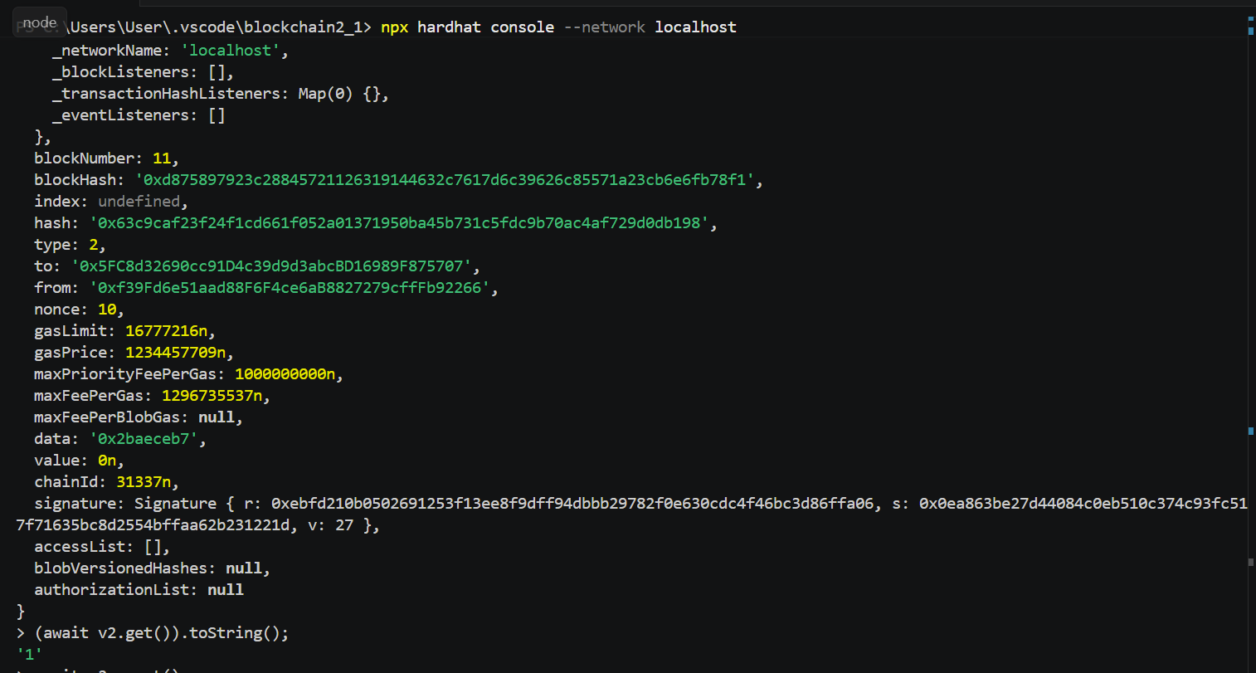
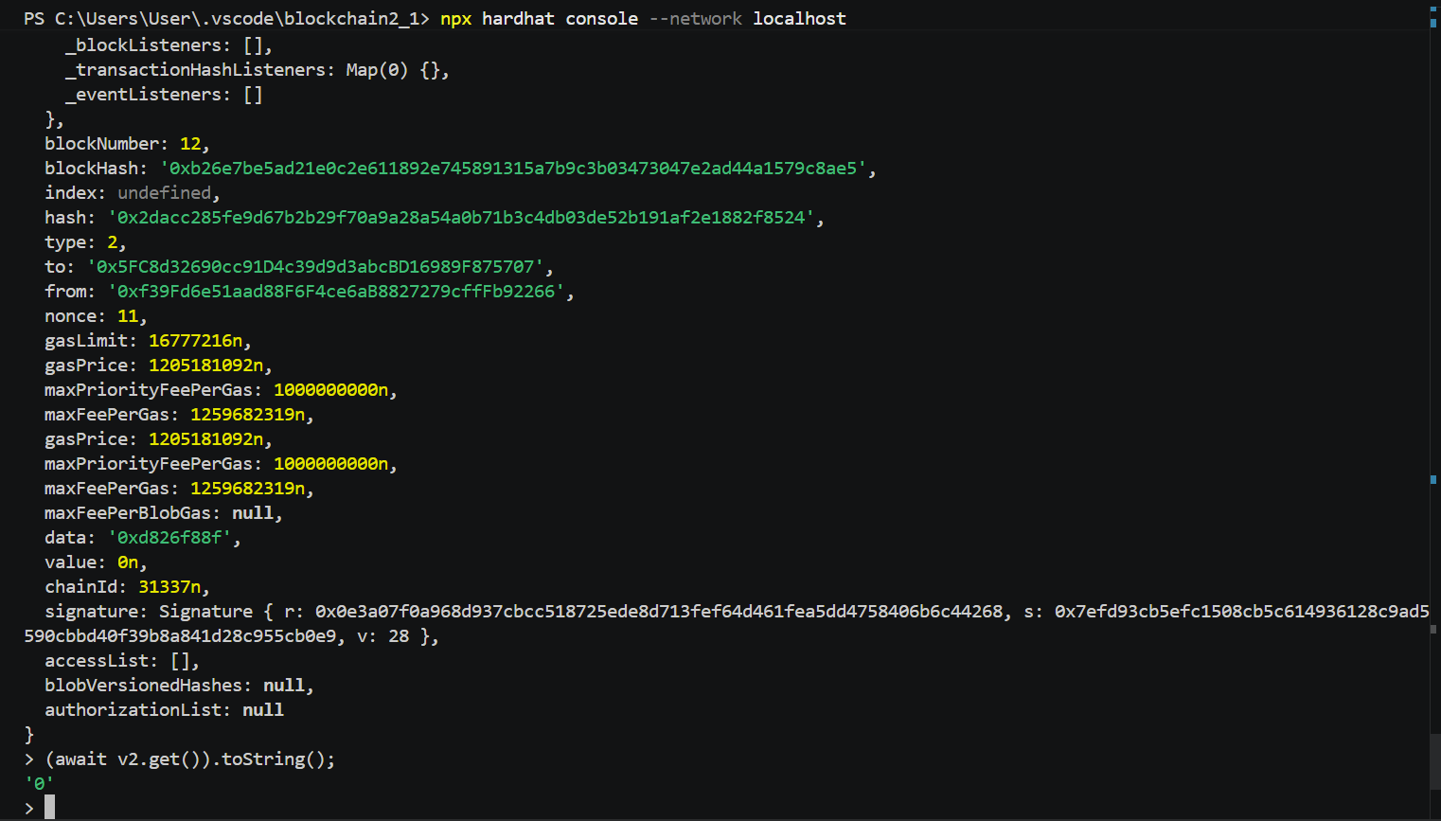
6. How Proxy Works
The proxy contract stores all the state variables and delegates function calls to the implementation contract using delegatecall.
This means:
Storage remains in the proxy
Logic can be changed by upgrading the implementation contract
7. Why Initializers Are Used

Constructors are not used in upgradeable contracts because they are only executed during direct deployment.

Since the proxy pattern separates deployment and logic, initializer functions are used instead.
8. Storage Layout Considerations
Maintaining storage layout is critical in upgradeable contracts.
Rules followed:
No reordering of existing variables
No deletion of variables
Only new variables can be added at the end
Violating these rules can lead to storage corruption.

